Creative Technologies Professionalism

# The Game Developers Portfolio/Showreel

## What is a portfolio/showreel?

### Portfolio

Within the Creative Technologies sector, a portfolio is a collection of materials that exemplifies the owner’s skills, qualifications, and or education. These materials mostly consist of static documents or images that the owner considers to be a showcase of their best work.

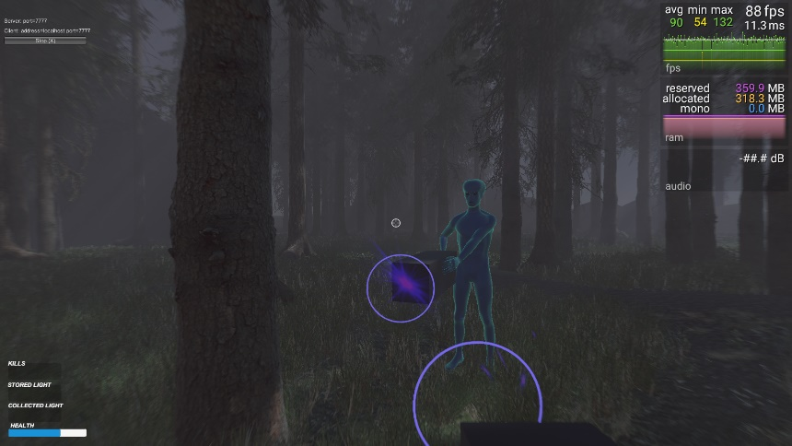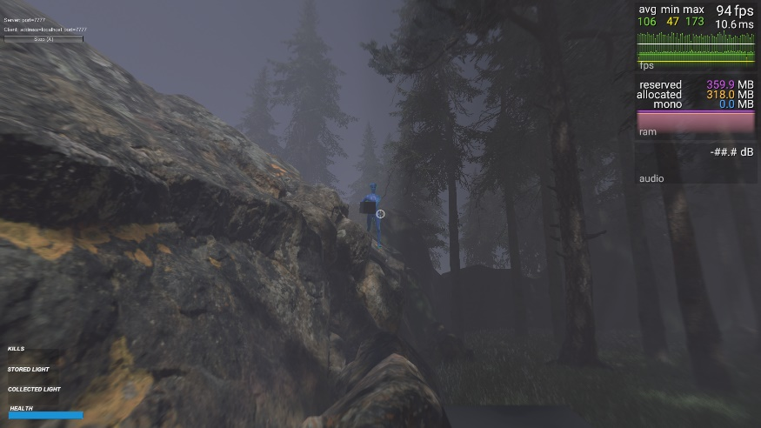

### Showreel

A showreel aims to do much the same although usually comes in the form of a video that is carefully composed to show the owners best work in action. Just like a movie trailer it gives a concise but captivating impression of the owner’s abilities within their given field.

## Do game developers need a portfolio/showreel?

I would have to say yes, and to both! From my own personal experience of applying for game development positions, there has never been one job advert that I have applied for that never requested a demo of my work. By stating “demo”, does that mean that you only post code examples, since the potential employer is looking for a demonstration of your coding skills?

Some would consider a showreel too artistic to include for a game developer, however, I think that it would be the best way to complement and present your finished coded examples. Allowing that potential employer to see a visual implementation of your code.

### The numbers don’t add up!

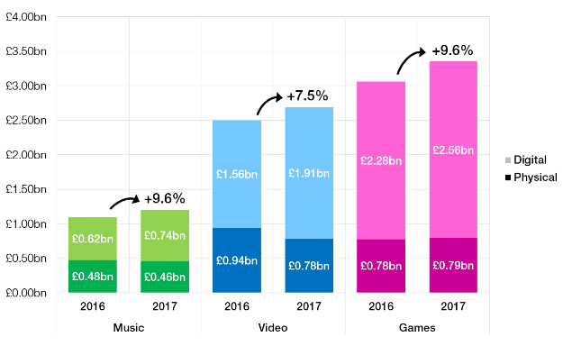Each year the computer games revenue grows, however, the jobs postings have declined by 65% since 2014. Exemplified in this statement posted on [Indeed.com](http://blog.indeed.com/2017/01/10/video-game-labor-snapshot/);

*“Overall, jobs for game developers and game designers have shown a strong decline since 2014 with a 65% drop in the percentage of postings. However, game developer job searches have grown over 50%.”*

With these numbers in mind it only goes to show that the competition for a job in game development right now is extremely fierce. Therefore, it only makes sense to have portfolio/showreel that makes you stand out from the crowd. Also, to help back this up even further below is an excerpt from [gamedesigning.org](https://www.gamedesigning.org/career/game-design-portfolio/)

*“A portfolio is the easiest and most effective way for you to show off the relevant work that you’ve done. The fact that most designers have their own portfolio somewhere on the web would mean that you’ve put yourself at a disadvantage by not making one yourself.”*

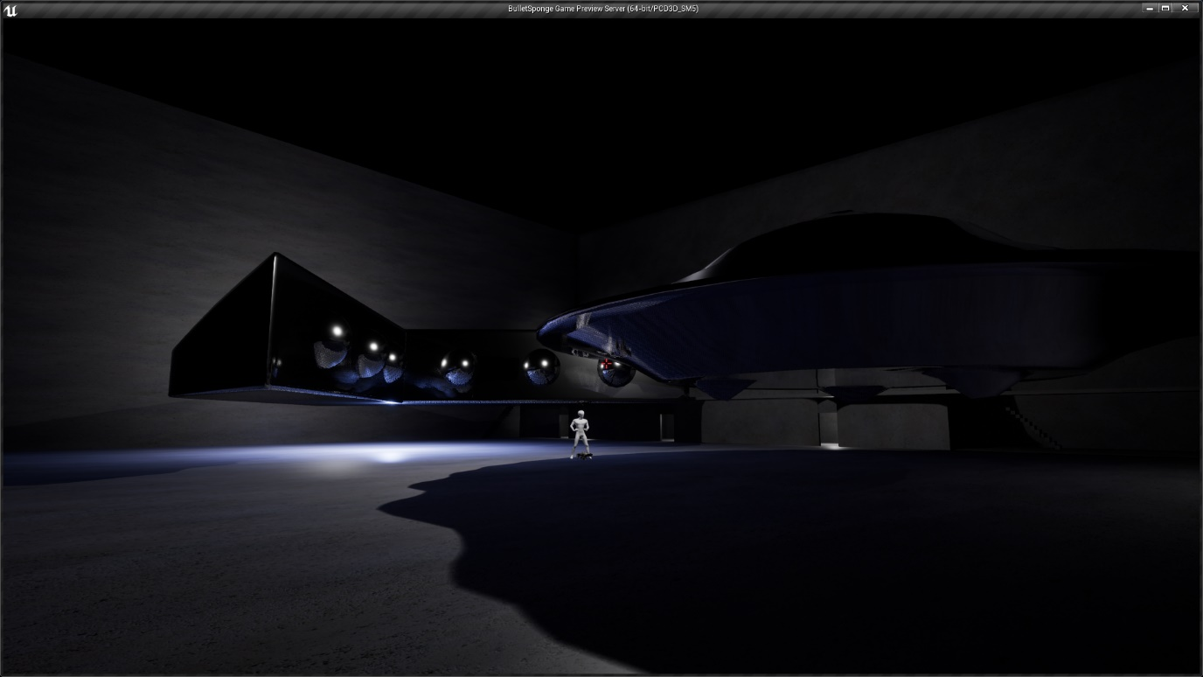

### Getting Noticed

To make your work stand out there are a few factors, in my opinion, that invariably count. First and foremost is that person viewing the portfolio should be drawn in by your best work. Personally, I don’t think that you should limit yourself to only your best work for display, as a wide range of work can show diversity.

Bearing in mind that you want to engage your viewer, therefore, the best examples should never be more than a click away from your landing page. The next main factor is relevancy. The main body of your portfolio should signify to the viewer that you are aiming towards a particular field. Since we are discussing this from a game developers’ point of view, it would make more sense to post the best examples of your games you have created first.

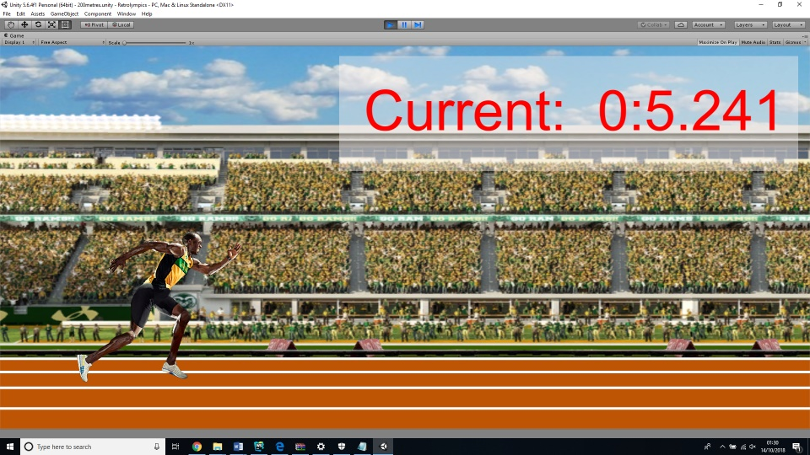This could be in the form of short video clips, source code posted via repository/version control software like GitHub or even links to access your own GDDs (Game Design Documents). If you put items like beautiful 3D models, sprites or 2d stills in the forefront, the viewer is more likely to think you are an artist or modeller rather than developer. This does not mean that you should exclude these types of work. Creative and wise organisation will make sure that they are not contributing to that ever so important first impression, yet still show your potential for diversity within the field.

### Summary

To conclude this post, I would urge anyone looking to apply for a position in Game Development to take note of key points above. They are by no means set in stone regulations that you must follow, but merely an opinion formed through experience and investigation into the subject. Who would you hire for the position, the person with real tangible evidence of their ability, or roll the dice and hope for sixes?

# Professionalism in Game Development

## What is Professionalism?

Before we get started, let’s just set out what we exactly mean by the term professionalism. In our case, Professionalism is the term used when describing the competence or skill expected of an individual or group, whilst adhering to a set of rules, or code of conduct laid out by professionals in that given field. I know that last statement was long winded and could easily make an insomniac sleep but bear with me and I will try to break it down further. Some attributes that can define professionalism are;

**Specialised knowledge** – Where an individual or group commit to develop and improve their skills within a particular field. Usually backed up with certification.

**Competency** – Getting the job done without any compromises and having the ability to deliver the results.

**Honestly and Integrity** – Sticking to values, doing the right thing.

**Accountability** – Full acceptance of responsibility

**Self-Regulation** – Keeping calm under pressure

**Image** – Looking the part

## Creative Industries

In my opinion professionalism ensures quality and progression by enforcing professional ideas and codes of conduct. Does this apply to the creative industries though? You would have to mad not to think so! With such a large industry that produces such high revenue, there has to be some form of professionalism driving it all or else, how did it become so big in the first place?

## Professional Bodies

Within the creative industries there are many different professional bodies that campaign to uphold professionalism. They can do this in several different ways such setting guidelines or codes of conduct, lobby for rights in parliament and even ensuring the quality of the workforce present.



TIGA is a trade association within the UK games industry that aims to strengthen the sector by “*campaigning for the industry in the corridors of power*”( <http://tiga.org/about-tiga-and-our-industry>) sounds a little egotistic, however, I believe they definitely benefit the games sector by ensuring Colleges and Universities meet the requirements of the industry and teach skills that are relevant. They also lobbied for Game Tax Relief and won and now they are currently campaigning for several other measures that would ensure growth by promoting start-up incentives for new businesses and small enterprises within the sector.

## Codes of Conduct

Codes of conduct are as important to the fishermen in our seas as they are to those people orbiting earth on the International Space Station as they are there to protect us from harm or corruption. So, it must go without saying, that codes of conduct must be there to protect those within the creative industries too. Ok so we are not going to be swallowed up by Moby Dick or lost in space, however, without the proper codes of conduct in place your rights to fair treatment and equality within the workplace would be severely compromised.

Within the games industry the International Game Developers Association (IGDA)( https://www.igda.org/) are governed by a Code of Ethics that they uphold to promote industry growth, a professional standard of workplace environment and to establish and publicly communicate those standards as professionals. This basically means that they try to offer a fair level playing ground where everyone has a voice and can feel safe from mistreatment. What is this mistreatment that we talk about? I thought everyone had to clean the toilets with a toothbrush at some point in their career? The creative industries can be a highly demanding sector with fast approaching deadlines and almost impossible budgets in some cases. IGDA protect both the employer and employee by making sure we are not over worked or underpaid, but at the same time ensure we don’t try to pass of the next Minecraft or Fortnite success story as our own or even sell it to the competitors.

# Freelancing

## Only for the initiated?

Freelancing can be a bit of a hit or miss subject when it comes to success. In my case I would consider it a miss for now as I have only just started my journey in professional games development and in my own personal view I don’t offer enough of a honed skillset to quantify becoming a freelancer. I’m not totally against the idea, although I do think that I would have to feel somewhat confident in the chosen task to accept it.

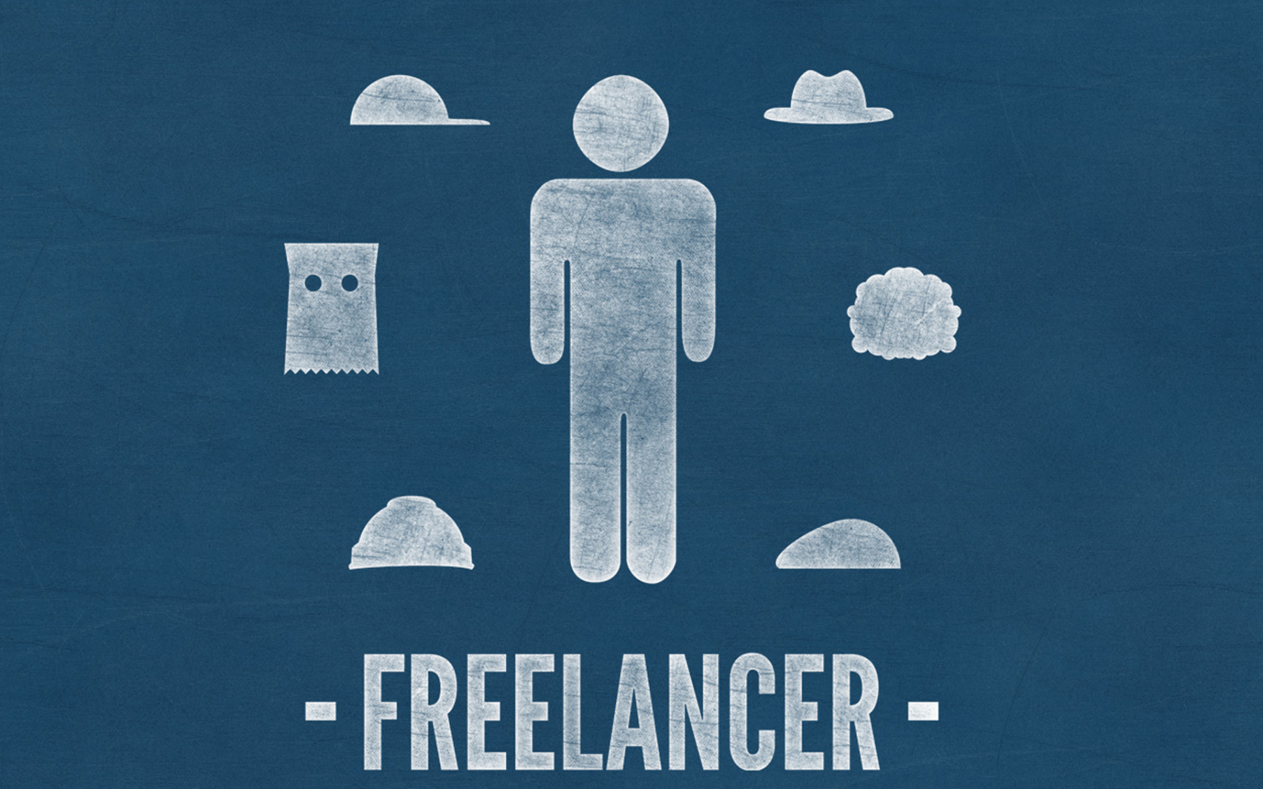

## The Friendly Professional

For the established professional within the creative industries free lancing could undoubtedly be the key to success. I would imagine that after working in a given field for several years that you would tend to build up a large network of associates who would be accustomed to your work ethics, personality and standards. In such cases this could possibly allow you to tender greater deals through working within a niche that you are familiar and respected. This was exactly the situation for a guest speaker we had come to one of my university lectures. He had worked in the field of Architecture for may years, so many that he had commanded some top tier corporate positions and rather than producing as he put it “beautiful images” he was telling others how they should be producing them. The reason he got those top tier positions in the first place ultimately allowed him to take up freelancing and get back to producing “beautiful images”.

## Two Sides of the Coin

Let’s look at what seem to be the obvious benefits of freelancing. You get to be your own boss, freedom to work to a schedule that you feel content with, possibly travel to exotic locations. All sound rather appealing, however, its not all fun and games as a freelancer. There are some caveats too, such as the reality that work is not always going to be there 100% of the time, the higher risk of not actually being paid for completed work. Which believe it or not does actually happen in the freelancing business.

## Is it for me?

Personally, I feel that freelancing as a game developer could be quite difficult in comparison to the situation that the speaker I previously discussed was in. Game developer contracts mostly run for longer periods of time, therefore they are generally brought in for the long haul rather than looking for freelancers. This does not mean there are no game developer freelance jobs up for grabs, here is a link to a freelancer source(https://www.freelancer.co.uk/jobs/game-development/), however, through my investigation they are very limited in comparison to other fields such as web or design, also the rewards for your efforts seems quite low in my opinion. As I have stated earlier, I am in my infancy within the games development world, which suggests that I truly do not know if there is any opportunities out there for myself in freelancing at this stage. Only time will tell.

# Networking

What is networking? Networking in terms of this discussion will be regarding the network of friends and associates that a person comes into contact with throughout their career and exchanges and retains contact details.

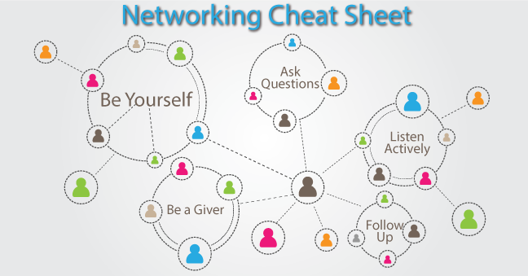

## Should I be doing it?

Within the creative industries networking is not only an option but, in my view, it is an absolute necessity. If you read my previous post regarding freelancing, you would understand that it is the fundamental lifeblood of being a successful freelancer. However, that does not mean that you should only consider networking if you fall into that category. Networking gets you connected with other like-minded individuals who can offer advice, help in the form of the skillset they can bring to a project and more importantly a foot in the door of a company. Cutting yourself off from the community could be just as detrimental as cutting of your own oxygen supply. You will be starved of work opportunities the same way as your lungs are starved of air giving that suffocating feeling of impending doom. Ok, maybe a bit too far but it’s definitely not a good idea, so you should be doing it regardless.

## How do I go about it?

Networking can be accomplished in many different ways. Simple things like going to events with like minded people and introducing yourself into the community. Yet again I will reference a university lecture where the guest speaker gained employment by using this exact technique. Things like game jams and hackathons are ideal location for a developer to get connected with others. We can also use more specialised ways of networking like social media, however, this is not the best idea, as bringing your personal life into career networking can also have its drawbacks. Such as there’s a higher chance of an old friend or acquaintance from your personal life that can inadvertently mess with your chances by mentioning something inappropriate to the subject of your career. There are different and more appropriate mediums however and can offer the wide reach that social media can. So, what is this magic I talk about? LinkedIn(https://uk.linkedin.com/). It is one the largest career networking platform that I am aware of for the creative industries and can target you directly towards your chosen field and most of the people worth connecting to in it. There are other options such as AngelList(https://angel.co/) and Meetup(https://www.meetup.com/), 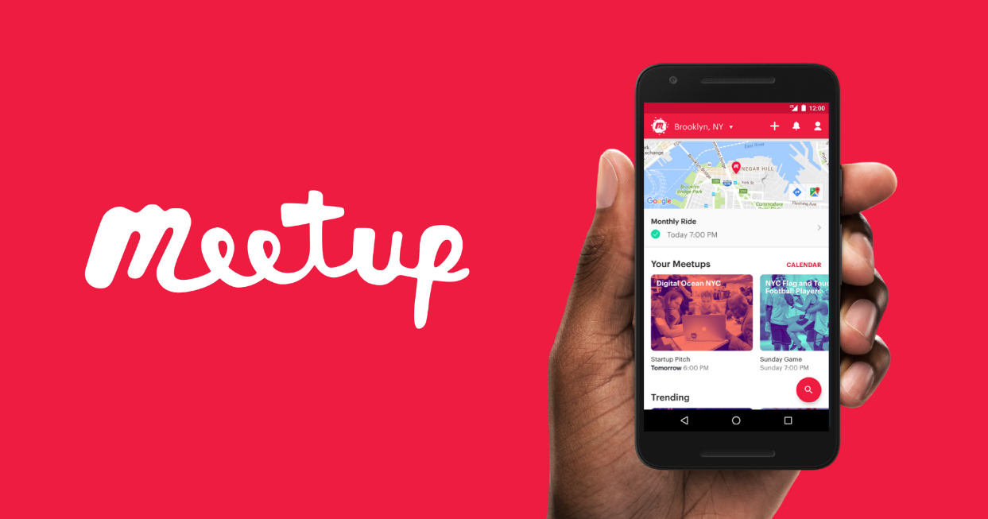 however, LinkedIn is to career networking, is what Facebook is to social media. If you want to be part of that circle, then you must get involved. Just try to be cautious with who you connect with as there’s no point connecting to a load of unrelated people that will only make you harder to find or harder for you to find others of more importance to yourself.

# Intellectual Property within the Creative Industry

## What is IP?

## 

Intellectual property rights or IP for short are the rights given to persons over the creations of their minds. Basically, marking ownership of a particular idea or creation, so that others can not simply take that idea as their own. In the UK you can apply for copyright, patent, design rights, and trademark to protect your ideas legally.

* Copyright is for media such as literature, audio and video.
* Patents are used to protect inventions.
* Design Rights protects the visual design of marketable product.
* Trademarks are distinguishable signs, designs or expression that identify products or services. Such as company logos or branding.



The first recorded UK copyright act dates as far back as 1709 and is commonly referred to as the “Statute of Anne” (https://www.copyrighthistory.com/quotations.html) due to it being passed during the reign of [Queen Anne](https://en.wikipedia.org/wiki/Anne,_Queen_of_Great_Britain).

## Does IP Stifle Creativity?

Generally speaking, I would say that IP does not stifle creativity within the creative industries although there are some instances in which it does. Take the recent case that happened between Samsung and Apple (https://www.nytimes.com/2018/06/27/technology/apple-samsung-smartphone-patent.html) over a number of design and utility patents. Apple sued Samsung saying that they had copied basic smart phone functions like tap to zoom and the app grid, features that are common place on almost all handheld devices today. Now, come on. Basic features like that being the sole property of one company? That just doesn’t seem right. In my opinion I would say that type of control would only be a natural progression for these types of devices with their touch functionality and small size, also taking into account the control expectations of their desktop brethren. Another situation that leads me to think this is the way that my 1-and-a-half-year-old daughter can easily pick up her big sisters’ tablet, swipe to unlock, then proceed to scroll through the apps until she finds YouTube, then can find individual videos like Baby Shark (do, do, do dodo). This natural ability to control this device for such a young child makes me believe that such control was merely a natural progression rather than a case of copying. With this in mind putting a block on such functionality for others product developers inherently stifles creativity.

## Games Development and IP

Within the game development sector, I believe that IP is just as important to help protect creative works of individuals or groups as it is in any other sector. The creative rights and ownership of game developers is just as important, however, in my opinion the way they are defined clearly speculates a broad definition since we see clones of the next big game literally months after the original pioneer was released.

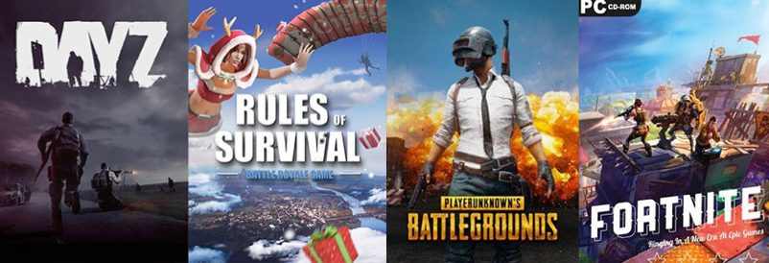

Look at games like Fornite, and PUBG for instance. The whole gameplay scenario between these games is very similar and obviously a winning formula. So much so that the giants that own the Call of Duty series have now jumped on the bandwagon and will probably clear up. Which to me seems rather unfair to the indie developers that created the first instalments of the battle-royale game genre. Leading me to believe that IP is so important that it probably needs greatly improved to protect the little guy.